04/09/2024

**Command to list files & directories**

1. List all files and directories in the current directory:

🡺 ls

2. List files with detailed information (permissions, size, modification date):

🡺ls -l

3. List all hidden files in the current directory

🡺ls -a

4. List files in current directory

🡺ls -lS

5. List files in directory sorted by modification time:

🡺ls -lt

6. Recursively list all files and directories under current directory

🡺ls -R ls -lt

7. Display file sizes in human-readable format in current directory

🡺ls –lh

8. List only directories in current directory:

🡺 ls -d

9. List all .txt files in current directory

🡺ls *.txt

10. List files in current directory starting with "photo"

🡺ls /c/Users/DELL/Desktop/Pushpa/Documents/Photo*

11. Display inode numbers of files in /home/user/pictures

🡺 ls -i /home/user/pictures

12. Show file permissions in octal format in /etc:

🡺stat -c '%a' data.csv (for single file)

13. List files with no group in current directory

🡺find -nogroup

14. Sort files by type in current directory

🡺ls -lX

15. List files in /var/www with multiple options (detailed, hidden, sorted by time)

🡺ls -lat

**Copying Files and Directories**

16. Copy gmail.txt from /c/Users/DELL/Desktop/Pushpa to /c/Users/DELL/Desktop/Pushpa/Documents

🡺 cp -r /c/Users/DELL/Desktop/Pushpa/gmail.txt /c/Users/DELL/Desktop/Pushpa/Documents/

17. Copy file1.txt, file2.txt, and file3.txt to /home/user/archive:

🡺cp file1.txt file2.txt file3.txt /home/user/archive/

18. Copy the entire projects directory to /home/user/backup:

🡺cp -r /home/user/projects /home/user/backup/

19. Copy data.csv to /home/user/archive while preserving attributes:

🡺cp -p data.csv /home/user/archive/

20. Copy report.txt to /home/user/backup, creating a backup of any existing file:

🡺cp --backup=numbered report.txt /home/user/backup/

21. Copy config.yaml to /etc/backup, prompting before overwriting:

🡺cp -i config.yaml /etc/backup/

22. Copy images/ directory to /home/user/pictures, showing the progress:

🡺cp -r --progress images/ /home/user/pictures/

23. Copy symbolic links from /home/user/links to /home/user/archive:

🡺cp -r --preserve=links /home/user/links /home/user/archive/

24. Copy project/ directory to /home/user/backup using archive mode

🡺cp -a /home/user/project/ /home/user/backup/

25. Copy files from /home/user/work to /home/user/backup, updating only newer files

🡺cp -u /home/user/work/* /home/user/backup/

26. Copy all files from /home/user/documents to /home/user/archive excluding .log files

🡺rsync -av --exclude='*.log' /home/user/documents/ /home/user/archive/

27. Copy docs/ to backup/, preserving attributes and displaying the operation

🡺cp -a -v docs/ backup/

28. Copy all files larger than 500MB from /var/logs to /home/user/archive

🡺find /var/logs -type f -size +500M -exec cp {} /home/user/archive/ \;

29. Copy and rename draft.txt to final.txt in /home/user/docs

🡺cp /home/user/docs/draft.txt /home/user/docs/final.txt

30. Recursively copy /home/user/projects to /backup, excluding the tmp folder

🡺rsync -av --exclude='tmp/' /home/user/projects/ /backup/

**Moving and Renaming Files and Directories**

31. Move notes.txt from /home/user/documents to /home/user/backup:

🡺mv /home/user/documents/notes.txt /home/user/backup/

32. Rename old_report.txt to new_report.txt in /home/user/reports:

🡺mv /home/user/reports/old_report.txt /home/user/reports/new_report.txt

33. Move file1.txt, file2.txt, file3.txt to /home/user/archive:

🡺mv file1.txt file2.txt file3.txt /home/user/archive/

34. Move data.csv to /home/user/archive, overwriting existing files:

🡺mv -f data.csv /home/user/archive/

35. Move the projects directory to /home/user/backup

🡺mv /home/user/projects /home/user/backup/

36. Rename old_photos to archive_photos in /home/user/pictures

🡺mv /home/user/pictures/old_photos /home/user/pictures/archive_photos

37. Move all .jpg files from /home/user/downloads to /home/user/images

🡺mv /home/user/downloads/*.jpg /home/user/images/

38. Move draft.txt to a new directory /home/user/work_archive

🡺mkdir -p /home/user/work_archive && mv draft.txt /home/user/work_archive/

39. Create a backup of database.db before moving it to /var/backups

🡺cp database.db database.db.bak && mv database.db /var/backups/

40. Move all files and directories from /home/user/temp to /home/user/final

🡺mv /home/user/temp/* /home/user/final/

41. Move config.yaml to /etc/backup, prompting before overwriting

🡺mv -i config.yaml /etc/backup/

42. Simulate moving important.docx to /home/user/trash and then move it back

🡺mv -n important.docx /home/user/trash/

🡺mv /home/user/trash/important.docx /home/user/

43. Move video.mp4 from drive C: to an external drive

🡺mv /mnt/c/video.mp4 /mnt/external_drive/

44. Move and rename file.txt to /home/user/docs/new_file.txt

🡺mv file.txt /home/user/docs/new_file.txt

45. Move projects/ directory to /backup, showing each file being moved

🡺mv -v projects/ /backup/

**Tail Commands for Viewing Logs**

46. Display the last 10 lines of log.txt in /var/log

🡺tail -n 10 /var/log/log.txt

47. Continuously monitor system.log for new entries

🡺tail -f /var/log/system.log

48. Display the last 20 lines of messages.log in /var/log

🡺tail -n 20 /var/log/messages.log

49. Monitor access.log and error.log in real-time

🡺tail -f /var/log/access.log /var/log/error.log

50. Display the last 50 lines of output.log in /home/user/logs

🡺tail -n 50 /home/user/logs/output.log

51. Show the last 10 lines of file1.txt, file2.txt, and file3.txt:

🡺tail -n 10 file1.txt

**05/09/2024**

**Find command**

1. Search for file Java.txt in above dir.

🡺find /c/Users/DELL/Desktop/Pushpa -name "Java.txt"

2.Search for all files ending with .log in the above directory

🡺 find /c/Users/DELL/Desktop/Pushpa/linux-content -name "*.log"

3.Find files larger than 10MB in the given directory

🡺 find /c/Users/DELL/Downloads -size +10M

4.Find files in /c/Users/DELL/Desktop/Pushpa modified in the last 7 days.

🡺 find /c/Users/DELL/Desktop/Pushpa -mtime -7

5. Find empty files in the above directory.

🡺find /c/Users/DELL/Desktop/Pushpa -type f –empty

6.Search for directories in the /c/Users/DELL/Desktop/Pushpa directory

🡺 find /c/Users/DELL/Desktop/Pushpa -type d

7. Find and delete all .tmp files in the /c/Users/DELL/Desktop/Pushpa directory.

🡺find /c/Users/DELL/Desktop/Pushpa -name "*.tmp" –delete

8. Find files in /c/Users/DELL/Desktop/Pushpa with permissions set to 755 (read=2, write=4, execute=1 for owner; read and execute for group and others).

🡺find /c/Users/DELL/Desktop/Pushpa -perm 755

9. Find files in /c/Users/DELL/Desktop/Pushpa owned by the user Dell.

🡺find /c/Users/DELL/Desktop/Pushpa -user Dell

10. Write the command that would find all .sh files in the /c/Users/DELL/Desktop/Pushpa directory and make them executable by adding execute permissions.

🡺find /c/Users/DELL/Desktop/Pushpa -name "*.sh" -exec chmod +x {} \;

11. Search for a file by its inode number in /c/Users/DELL/Desktop/Pushpa.

🡺find /c/Users/DELL/Desktop/Pushpa -inum 3377699720921428

12. Find files in /c/Users/DELL/Desktop/Pushpa that match the regular expression for filenames containing "config".

🡺find /c/Users/DELL/Desktop/Pushpa -regex ".*/config.*"

13. Find files in /c/Users/DELL/Desktop/Pushpa that have been accessed in the last 10 days.

🡺find /c/Users/DELL/Desktop/Pushpa -atime -10

14. Find .jpg files in /c/Users/DELL/Desktop/Pushpa/Documents and move them to the /Resume directory.

🡺find /c/Users/DELL/Desktop/Pushpa/Documents -name "*.jpg" -exec mv {} /Resume \;

15.Find .txt files in /c/Users/DELL/Desktop/Pushpa, but exclude the /c/Users/DELL/Desktop/Pushpa/linux-content directory

🡺find /c/Users/DELL/Desktop/Pushpa -name "*.txt" -not -path "/c/Users/DELL/Desktop/Pushpa/linux-content*"

**Grep command:**

1. Search for the string "assets" in the /var/log/system.log file.

🡺grep "assets" /c/Users/DELL/Desktop/Pushpa/linux-content/access.log"

2. Recursively search for "TODO" in Python files (*.py) inside /c/Users/DELL/Desktop/Pushpa/linux-content.

🡺grep -r "TODO" /c/Users/DELL/Desktop/Pushpa/linux-content --include="*.py"

3. Case-insensitive search for "Pushpa" in the command.csv

🡺grep -i "Pushpa" command.csv

4. Count the number of occurrences of the string "Pushpa" in command.csv

🡺grep -c "Pushpa" command.csv

5. Search for "Viju" in command.csv and display the line numbers where it occurs.

🡺grep -n "Viju" command.csv

6. Search for "PUSHPA" in command.csv and display 3 lines of before and after each match.

🡺grep -C 3 "PUSHPA" command.cs

7. Search for all lines in class.txt that do not contain the word "class".

🡺grep -v "class" Java.txt

8. Search for the whole word "class" in Java.txt

🡺grep -w "class" Java.txt

9. Search for lines in Java.txt that start with "The".

🡺grep "^The" Java.txt

10. Search for lines in Java.txt that contain either "class" or "cat" using extended regex.

grep -E "class|cat" Java.txt

11. Search for the string "class" in Java.txt and highlight matches with color.

🡺grep --color=auto "class" Java.txt

12. Search for the string "Pushpa" in both command.csv and bridge.csv files.

🡺grep "Pushpa" command.csv bridge.csv

13. Search for the string "timeout" in .conf files in /etc and list only the filenames containing the match.

🡺grep -l "timeout" /etc/*.conf"

14. Filter the output of the netstat command(display information about network) for lines containing "assets".

🡺netstat | grep "assets"

15. Search for lines containing "class" in Java.txt, but exclude lines that also contain "teacher".

🡺grep "class" Java.txt | grep -v "teacher"

**Environment Variables:**

1. prints the current environment variables and filters the output to show only the PATH variable

🡺env | grep "PATH"

2. used to remove the EDITOR environment variable and then print its value.

🡺unset EDITOR && env | grep "EDITOR"

3. Specify the interpreter for the script(to use the Bash shell to execute the script.)

🡺#!/bin/bash

4. Prints the value of the environment variable HOME

🡺echo $HOME

5. Set the USER environment variable to guest and starts a new Bash shell to execute the command echo $USER

🡺env USER=guest bash -c 'echo $USER'

6. Runs a new Bash shell in the current environment. All environment variables from the current session will be inherited by the new shell.

🡺env bash

**09/09/2024**

**Data analysis/Manipulation(usig awk command)**

1. Print Employee name & TotalPay who has basePay greater than 10000

🡺awk -F',' '$4 > 10000 {print $2, $7}' data.csv

2. Read data file data.csv and extract rows which have BasePay>10000

🡺awk -F',' '$4 > 10000' data.csv

3.What is the aggregate TotalPay of employee whose job title is 'CAPTAIN'

🡺awk -F',' '$3 == "CAPTAIN" {sum+=$7} END {print sum}' data.csv

4.Extract TotalPay and calculate sum. print the result

🡺awk -F',' '{sum+=$4} END {print sum}' data.csv

5.Print JobTitle and OverTimePay who has OverTimePay is Between 7000 and 10000

🡺awk -F',' '$5 >= 7000 && $5 <= 10000 {print $3, $5}' data.csv

6.Read file data.csv and extract BasePay values and calculate its average

🡺awk -F',' '{sum+=$4; count++} END {if (count > 0) print $4,sum/count}' data.csv

**17/09/2024**

**File Management commands**

1. Display the maximum file with human readable file size

🡺ls –lhS | head –n 2

2.Create multiple hard links to file.txt called file_link1, file_link2, and file_link3

🡺ln file.txt file_link1 file_link2 file_link3

3.Adds execute permission for the owner of file.txt

🡺chmod u+x file.txt

4.Removes write permission for the group of file.txt

🡺chmod g-w file.txt

5.Sets read permission for others on file.txt

🡺chmod o=r file.txt

6.Identify all files in ‘/var/log’ that are larger than 500MB and modified in the last 30 days, move them to a backup directory ‘/backup/logs/’

🡺find /var/log -type f -size +500M -mtime -30 -exec mv {} /backup/logs/ \;

7.Copy the entire directory to another directory

🡺cp –a <path_dir1_copy> <path_dir2_move>

8.Recursively change the permissions of all files in current directory to 644

->find -type f -exec chmod 644 {} \;

9.Find all the files in the ‘/Resume’ directory which are older than 3 days and move to the ‘tmp’ directory.

**🡺**find /Resume –type f –mtime -3 -exec mv {} /tmp \;

10.Create 3 nested folders

**🡺**mkdir abc/pqr/def

11. List all hidden files and directories in current dir, sorted by modification time in reverse order

🡺ls –latr

12.List only files in current directory, excluding directories

🡺ls –p|grep –v

13.Find total size of files larger than 10MB in / current directory

🡺find -type f -size +10M –exec du -ch {} + | grep total$

14.Display disk usage of all subdirectories in current directory and sort them by size

🡺du -h --max-depth=1 | sort –rh

15.Find the files with permission 777

🡺find -type f -perm 777

16.Search for log files in current directory and remove (delete) them in single command

🡺find -type f -name “*.log” -exec rm {} \;

17. Change the date on specific file to match yesterday's date(16/09/2024)

🡺touch -d “16/09/2024” <file name>

18.List the files based on their modification time & display oldest one

🡺ls –lt |tail –n 1

19.List files modified in last 24 hours(1day)

🡺find -type f -mtime -1 -exec ls-lh {} \;

20.Display maximum 5 files based on their disk usage

🡺du -h | sort -rh | grep -v ‘/$’ |head -n 5

21. Rename all .txt files in ‘/home/user/’ reports to ‘.backup’

🡺find /home/user/reports -type f -name "*.txt" -exec rename 's/.txt$/.backup/' {} \;

22. Find the total disk usage of /var and list the top 5 largest directories

🡺du -ah /var | sort -rh | head -n 5

23. Find and delete .log files in /var/log that haven’t been modified in the last 90 days:

🡺find /var/log -type f -name "*.log" -mtime +90 -exec rm {} \;

24. Display the disk usage of each file individually in the /data directory, sorted by size.

🡺find /data -type f -exec du -h {} + | sort –rh

25. Search for the string "Pushpa" in both command.csv and bridge.csv files.

🡺grep "Pushpa" command.csv bridge.csv

26.Find all files larger than 500MB in current directory, then sort them by size in descending order

🡺find -type f -size +500M -exec ls -lh {} + | sort -k 5 –rh

27. Find all files in current directory that have permissions 777 (read, write, and execute) and change their permissions to 755

🡺find -type f -perm 0777 -exec chmod 755 {} \;

28. Find files owned by admin in current directory and change their ownership to developer?

🡺find -type f -user admin -exec chown developer {} \;

29. Display the disk usage of the top 10 largest directories under current root directory

🡺du -h | sort -rh | head -n 10

30. Find the total disk usage of files in current directory modified in the last 7 days

🡺find -type f -mtime -7 -exec du -ch {} + | grep total$

31. Find and display the disk usage of files larger than 10MB in the current directory

🡺find -type f -size +10M -exec du -h {} \;

32.Compare two files(file1.txt & file2.txt) and only show the first 10 differences

🡺diff file1.txt file2.txt | head -n 20

33. Copy only files from ‘/projects/’ to ‘/backup/projects/’ modified in the last 7 days?

🡺find /projects/ -type f -mtime -7 -exec cp {} /backup/projects/ \;

**Assignment 1 – File System Management**

1. List out 5 files in your system which consuming most of the disk space

-> find -type f -exec du -h {} \;|sort -rh | head -n 5

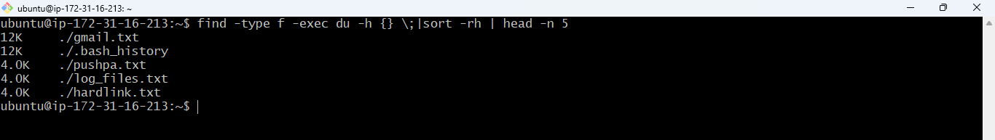

1. Create one common folder in such a way that anyone can create files inside that independently and should not be able to delete other users’ files from that common folder.

->mkdir /pushpa

->chmod 1777 /pushpa

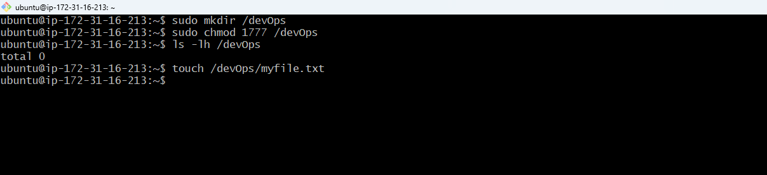

1. Create user name "shubham" and add that user in the group "adm"

->sudo adduser shubham

->sudo addgroup adm

->sudo usermod –aG adm shubham

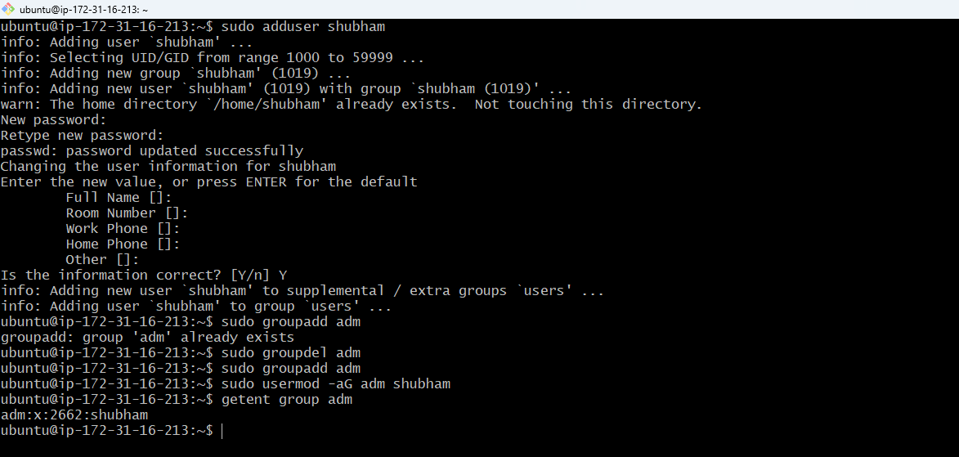

1. Create folder /data , change owner and group as "root:adm

->sudo mkdir /data

->sudo chown root:adm /data

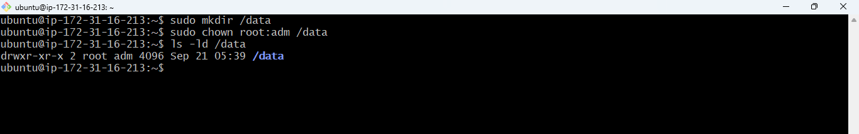

1. Change /data permission such a way that user can able to write data in this folder and ownership of files or folder which you creates in this folder should be same as parent folder i.e /data folder permission (root:adm)

->sudo chmod 2777 /data

